**11-20 notes**

Introduction to Flask and Serving data with APIs

Goals:

By the end of this lesson, you will be able to:

* Create and run a server by using Flask.
* Define endpoints by using a Flask decorator.
* Extract query-variable path values from GET requests.
* Run database queries on behalf of the client by using variable paths.
* Return JSON-ified query results from API endpoints.

***Flask is a way to run a web server on your computer.***

Remember- SQLAlchemy can use pure SQL to manipulate SQL databases, or a more Pythonic object-based approach can be used.

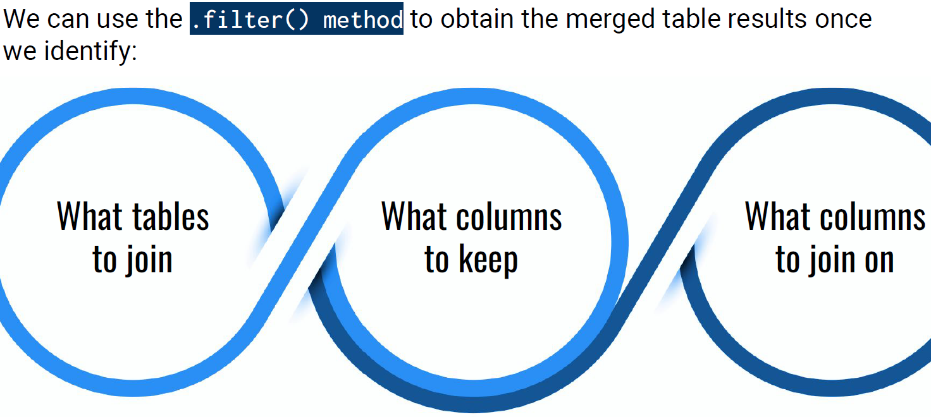

Important Note! Sqlite does not support a date column type, but SQLAlchemy will allow you to work with dates in the iso format. https://docs.sqlalchemy.org/en/20/dialects/sqlite.html

**JSONIFY solution:**

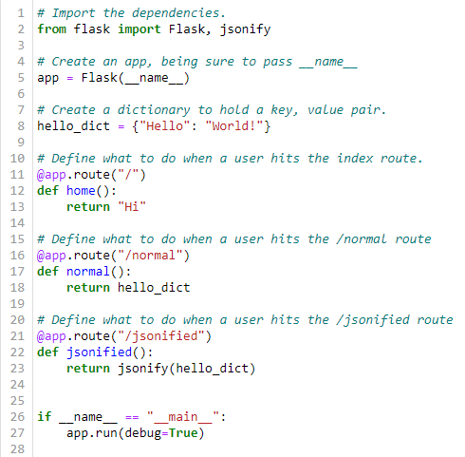

Variable Rule solution:

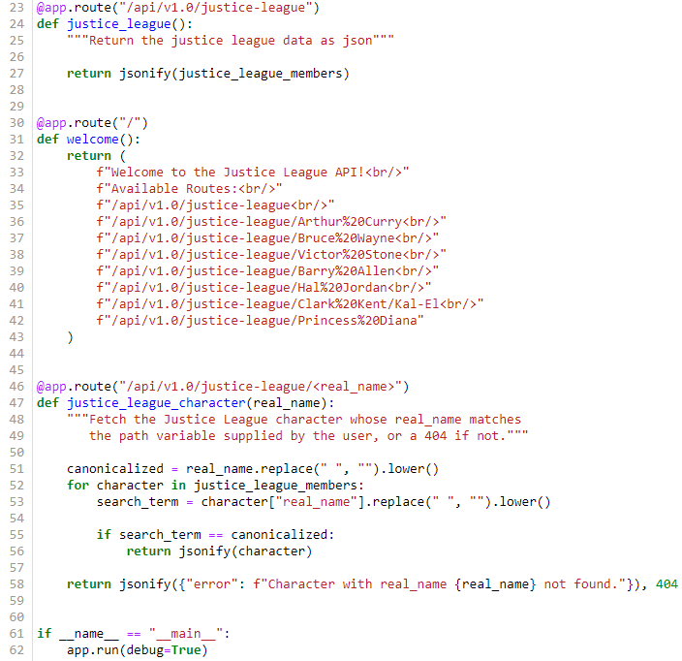

^ Lines 51-53 are standardizing the input you receive from the request.

It removes spaces and makes input all lowercase. That way you don’t get a 404 error for a name that’s capitalized.

